Ink Request - Printer - WF-C5890 Series - 2026

Objective
Copy the information below and paste it into an email body in Outlook; Recipient email: suporte@fmsdi.com.br; WhatsApp: (11) 2542-4444; Subject: CONTOSO - Supply Request for printer "WF-C5890 Series"
Hello, how are you?
Please find below the Material/Ink request for the 'WF-C5890 Series' printer.
Tax ID (CNPJ): 08.743.754/0004-96; Sender: CONTOSO; Address: Rua Doutor Candido Rodrigues, 23 – PO Box 1006 – Centro – Braganca Paulista/SP; ZIP: 12900-970; Printer: WF-C5890 Series; Serial No.: XBJZ023148; Ink/material: Black Ink; Availability for delivery: Mon–Fri 08:00 to 18:00; Ink level validation:
<END OF EMAIL>

Note:
Access <printer IP> through the browser, take a screenshot and insert it in the field above, or check the ink levels on the control panel, take a photo, and attach it.
Screenshot Example: Final email example:
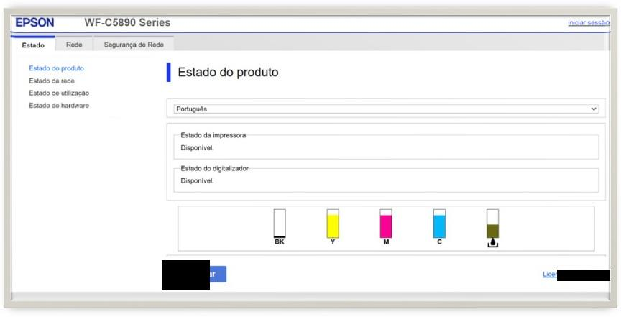

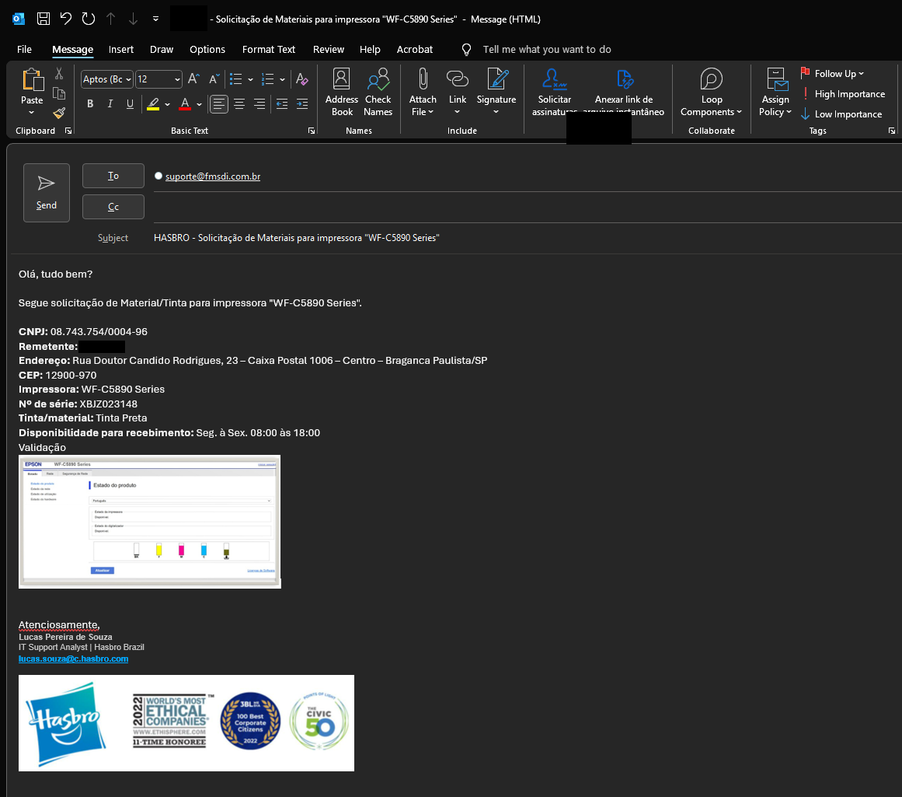

Version History
Author | Version | Date | Description
Lucas Souza | 1.0 | Jun/2026 | Document creation

